Editing a Time of Event on the user side to make it work and reset the status to pending:

Before:

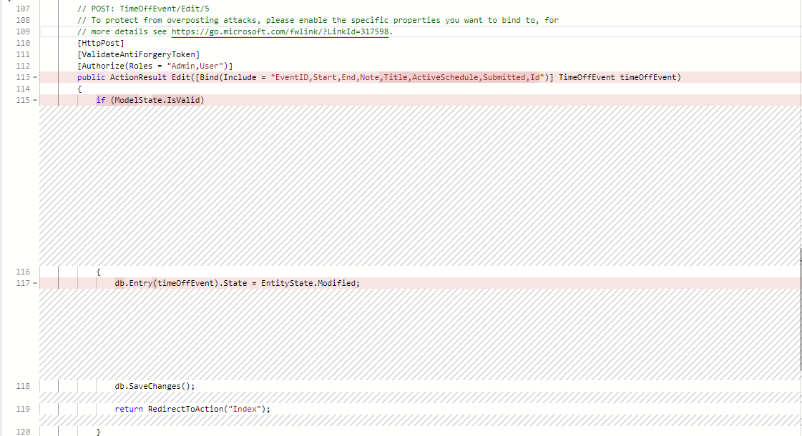

After:

